Using the NavBar

Basic Navigation
- Click on the compass icon in the upper right corner of the page to display the NavBar.
- Click or tap the Navigator button. This presents a menu list.
- Select the menu item and drill down to the page you would like to view.
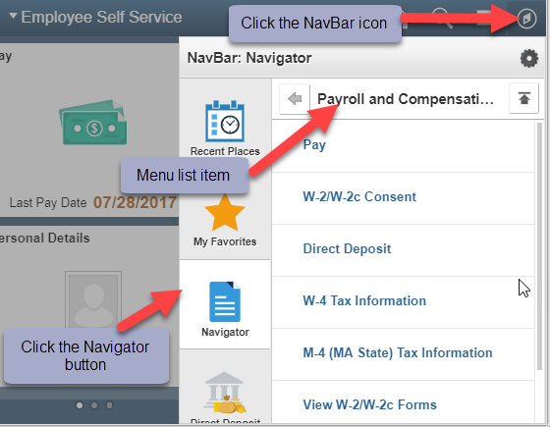

Adding to the NavBar
A customizable NavBar is a great feature for quick and easy navigation within HR Direct. Clicking on the shortcut icons in the NavBar will open the corresponding page automatically eliminating manual navigation.

Option 1: Navigating to a page and adding it to the NavBar
- Navigate to the page you want to add to your NavBar.
- Click on the Actions List icon in the top right hand corner and then select Add to NavBar from the menu list. This adds a shortcut to the current page onto the NavBar.
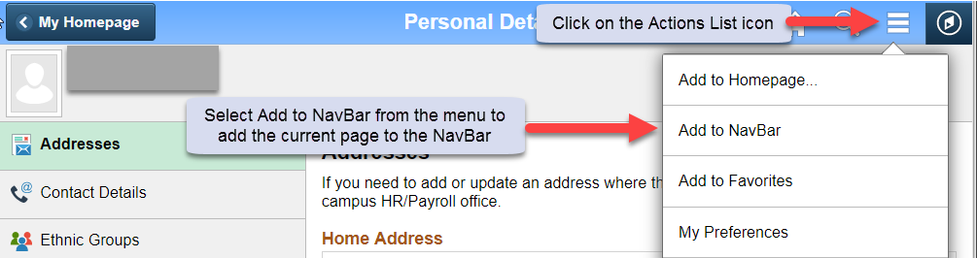

Option 2: Using the Personalize NavBar Feature
- Click on the NavBar icon in the upper right corner from any page. Click on the tools/gear icon in the upper right corner of the NavBar. This opens the Personalize NavBar feature.
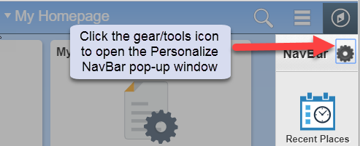
- Click on the Add Tile button in the upper right corner of the pop-up and locate the page you want to add.
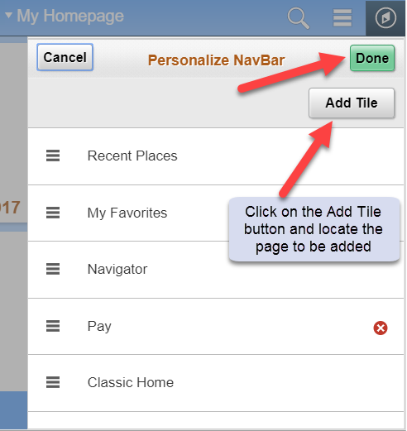
- Click the Done button in the upper right corner of the pop-up to save the changes to your NavBar.

Editing the NavBar
- Click on the tools/gear icon in the upper right corner of the NavBar. This opens the Personalize NavBar feature.
- Edit the NavBar:
  - Reorganize the order in which the icons appear by dragging and dropping the menu item to the desired place in the menu.
  - Delete a tile by clicking the red “X” icon next to the name of the page you want to delete.

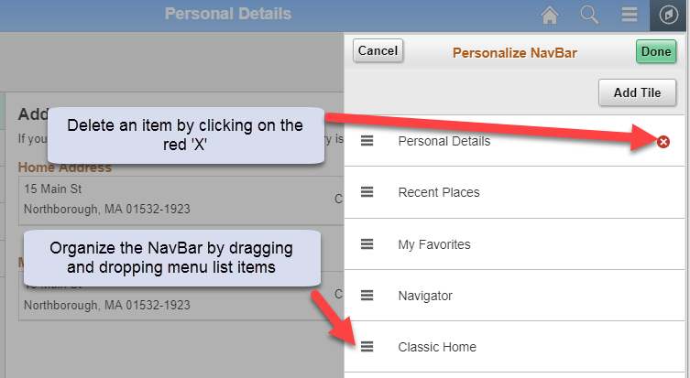
- Click the Done button to save the changes to the NavBar.

